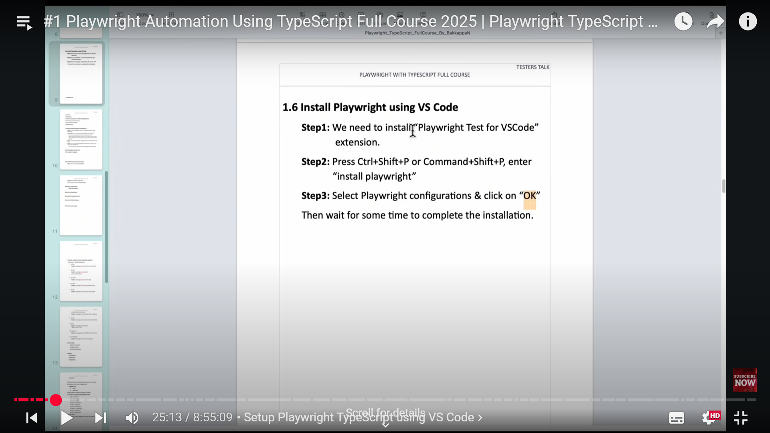

npx playwright test

Runs the end-to-end tests.

npx playwright test --ui

Starts the interactive UI mode.

npx playwright test --project=chromium

Runs the tests only on Desktop Chrome.

npx playwright test example

Runs the tests in a specific file.

npx playwright test --debug

Runs the tests in debug mode.

npx playwright codegen

Auto generate tests with Codegen.

We suggest that you begin by typing:

npx playwright test

And check out the following files:

- .\tests\example.spec.ts - Example end-to-end test

- .\tests-examples\demo-todo-app.spec.ts - Demo Todo App end-to-end tests

- .\playwright.config.ts - Playwright Test configuration